**Name : Ali Azhar**

**Roll No : SU92-BSAIM-S24-026**

**Section : 3A**

**Subject : Artificial Intelligence**

**Documentation of Task 1**

**“LUHN Algorithm”**

**Luhn Algorithm Documentation**

**Variables:**

* Sum_odd_numbers: Stores the sum of digits at odd positions.
* Sum_even_numbers: Stores the sum of digits at even positions after processing.
* total: Stores the final sum used for validation.
* card_number: User-input debit card number, cleaned and reversed.

**Process:**

1. Remove spaces and dashes from the input.
2. Reverse the card number.
3. Sum digits at odd indices.
4. Double digits at even indices:
   * If the result is 10 or more, sum its digits.
5. Compute the total sum.
6. If total is divisible by 10, the card is valid; otherwise, it's invalid.

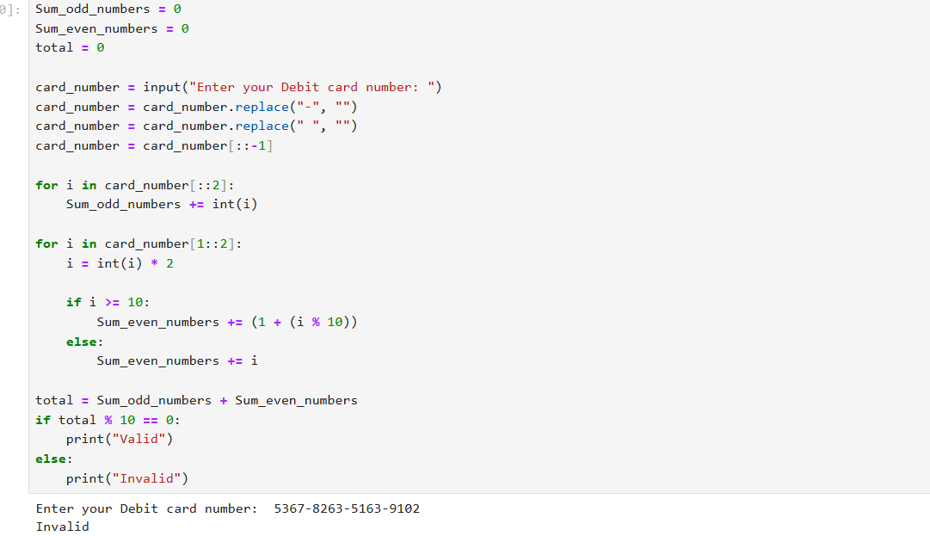

**Task 2 (Remove Punctuations)**

### ****Variables:****

* Punctuations: A string containing all special characters to be removed.
* String: User-input sentence or word.
* Empty_string: Stores the cleaned string without punctuations.

### ****Process:****

1. Take user input.
2. Iterate through each character in String.
3. If the character is not in Punctuations, add it to Empty_string.
4. Print the cleaned string.

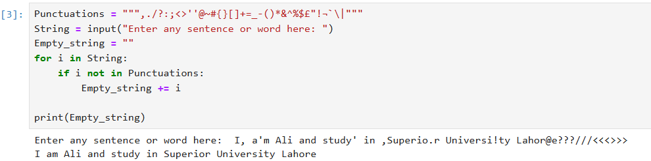

**Task 3 (Sort text (word) in Alphabetical Order)**

**ASCII Sorting Documentation**

### ****Function: Ascii_sorting****

### ****Parameters:****

* words: A list of words to be sorted.

### ****Returns:****

* A list of words sorted in ASCII order.

### ****Process:****

1. Use a nested loop to compare adjacent words.
2. Swap words if they are out of order based on ASCII values.
3. Continue until the list is fully sorted.

### ****Usage:****

* Takes a sentence as input.
* Splits it into a list of words.
* Sorts the words using ASCII values.

